Step 1:- Created New Job – Named Job 1

Step 2 – attached the dedicated salve agent named as slave1

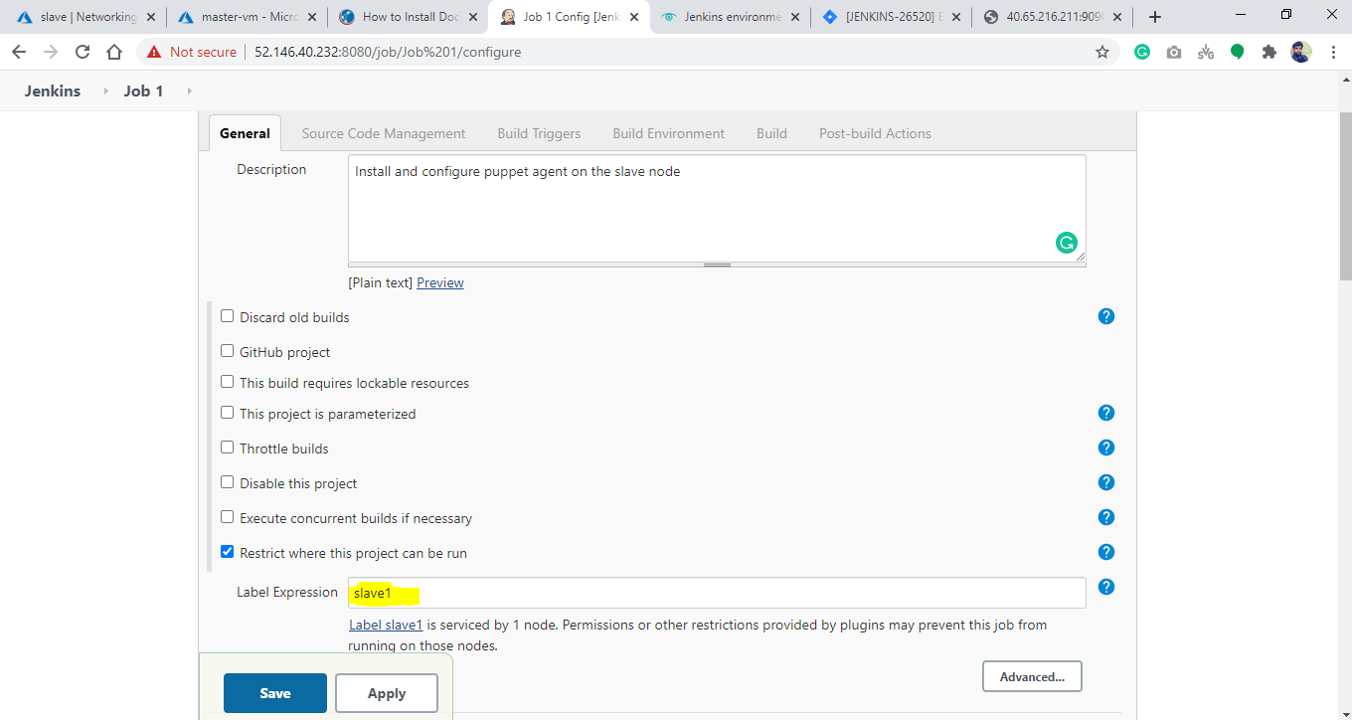

Step 3:- In Build Section – written some command to install and configure the puppet-agent on slave 1.

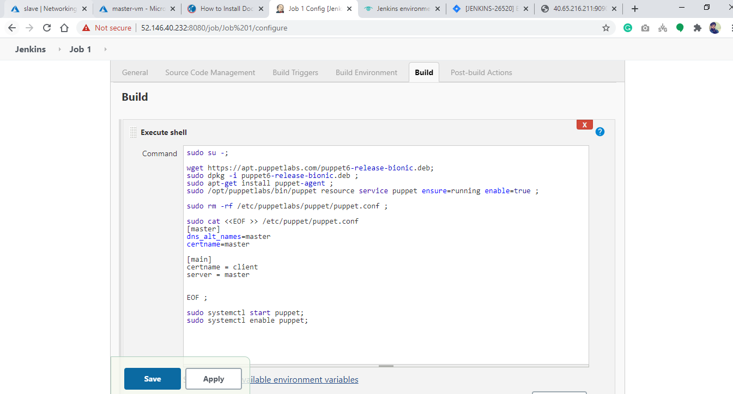

Step 4 – clicked on build now and puppet-agent got installed on slave node.

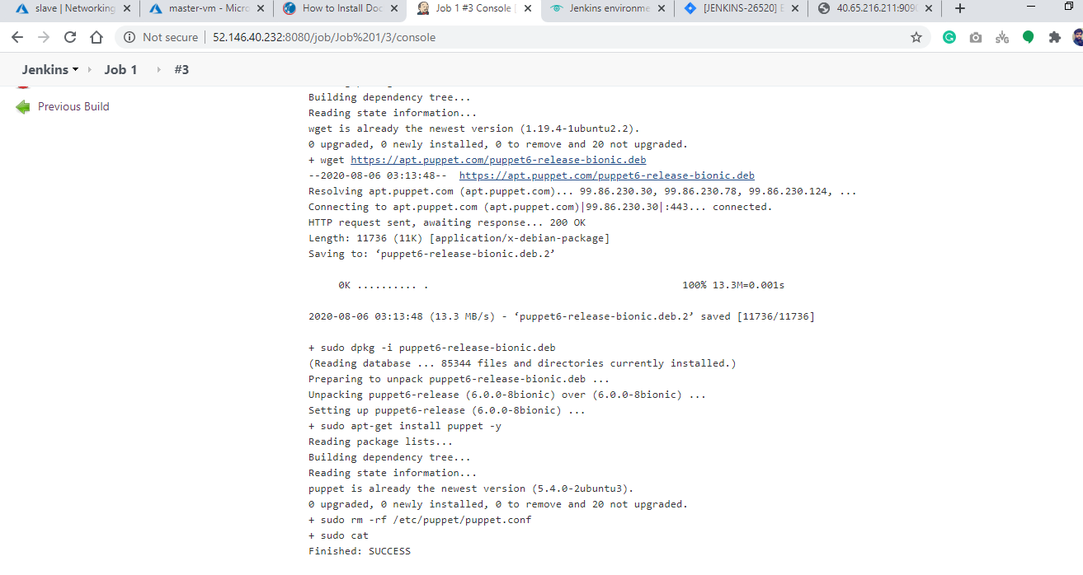

Note – Attached the log file in Build log folder.